**Data Security and Privacy in Big Data Analysis Using IBM Cloud Databases**

|  |  |
| --- | --- |
| **Date** | **10-10-2023** |
| **Team ID** | **4190** |
| **Project Name** | **Data Security and Privacy in Big Data Analysis Using IBM Cloud Databases** |

**Table of Contents**

|  |  |
| --- | --- |
| 1 | Introduction |
| 2 | Problem Statement |
| 3 | Design Strategies |
| 3.1 | Encryption and Tokenization |
| 3.2 | Access Control and Role-Based Authorization |
| 3.3 | Data Masking and Anonymization |
| 3.4 | Audit Trails and Monitoring |
| 3.5 | Compliance with Data Regulations |
| 4 | Innovation Strategies |
| 4.1 | Adversarial Machine Learning |
| 4.2 | Privacy-Preserving Machine Learning |
| 4.3 | Explainable AI (XAI) |
| 4.4 | Continuous Monitoring and Adaptive Learning |
| 5 | Conclusion |

**1. Introduction**

In the era of data abundance, organizations are accumulating massive datasets across diverse domains, presenting both opportunities and challenges. IBM Cloud Databases offer a robust platform for Big Data analysis, promising the discovery of valuable insights and data-driven adventures. and this project aims to utilize innovative approaches to enhance prediction accuracy and reliability.

**2. Problem Statement**

The project involves delving into big data analysis using IBM Cloud Databases. The objective is to extract valuable insights from extensive datasets, ranging from climate trends to social patterns. The project includes designing the analysis process, setting up IBM Cloud Databases, performing data analysis, and visualizing the results for business intelligence.

**3. Design Strategies**

**3.1 Encryption and Tokenization:**

To Protecting data at rest, in transit, and during process Implementing end-to-end encryption for data stored in IBM Cloud databases and during transmission and Leverage IBM Cloud Key Protect or a similar service for managing encryption keys securely by incorporating tokenization to replace sensitive data with tokens, reducing the exposure of actual data.

This Mitigates the risk of unauthorized access to sensitive information and ensures data confidentiality and integrity.

**3.2 Access Control and Role-Based Authorization:**

This Restricts the access to data based on user roles and responsibilities. Implementing fine-grained access controls to limit user privileges. Leverage IBM Cloud Identity and Access Management (IAM) for role-based access control and Regularly review and update access permissions based on the principle of least privilege.

It minimizes the risk of unauthorized data access or modification and Enables traceability of data access and actions.

**3.3 Data Masking and Anonymization**:

Safeguarding sensitive information while maintaining data utility. By applying data masking techniques to conceal specific elements of sensitive data and use anonymization to replace personally identifiable information (PII) with non-identifying values. Leverage IBM Cloud services for data anonymization or utilize pre-processing tools.

It Protects privacy by preventing the exposure of sensitive details. It Allows for the safe use of data in analytics without revealing individual identities.

**3.4 Audit Trails and Monitoring:**

Tracking and auditing data access and system activities.By implementing comprehensive logging mechanisms to capture user activities and system events. Using IBM Cloud Monitoring and Logging services to centralize log data. By Regularly reviewing audit trails for anomalies and unauthorized activities.

It Facilitates compliance with regulatory requirements and enables timely detection and response to security incidents.

**3.5 Compliance with Data Regulations:**

Ensuring adherence to relevant data protection regulations. By staying informed about data protection laws and regulations applicable to your industry and region.

Strategies like Design security and privacy measures in alignment with standards like GDPR, HIPAA, etc. By Utilizing IBM Cloud Compliance and IBM Cloud Security and Compliance Center to monitor and enforce compliance.

This Reduces legal and reputational risks associated with non-compliance and demonstrates a commitment to protecting user privacy and data.

**4. Innovation Strategies**

**4.1 Adversarial Machine Learning:**

Enhance the robustness of machine learning models against adversarial attacks. By Integrate adversarial training techniques to expose models to potential attack scenarios during training. This helps the model learn to resist manipulation attempts.

**4.2 Privacy-Preserving Machine Learning:**

Enable machine learning analysis while preserving the privacy of sensitive data.

Implement techniques such as federated learning or homomorphic encryption to train models across decentralized datasets without exposing raw data.

Allows for collaborative model training without sharing sensitive data, ensuring privacy compliance.

**4.3 Explainable AI (XAI):**

Provide transparency and interpretability to machine learning models for security decision-making

Integrate XAI techniques to make the decision-making process of models more understandable. This is crucial for identifying and mitigating biases and improving trust in the system.

Enhances trust in machine learning predictions, aids in auditing and understanding model decisions, and facilitates compliance with data protection regulations.

**4.4 Continuous Monitoring and Adaptive Learning:**

Continuously adapt to evolving threats through real-time monitoring and learning.

Implement systems that continuously monitor network and user activities, feeding this information back into machine learning models for adaptive learning. Use reinforcement learning to optimize security measures dynamically.

Enables proactive threat detection and response, adapting to new attack patterns and ensuring the system remains resilient over time.

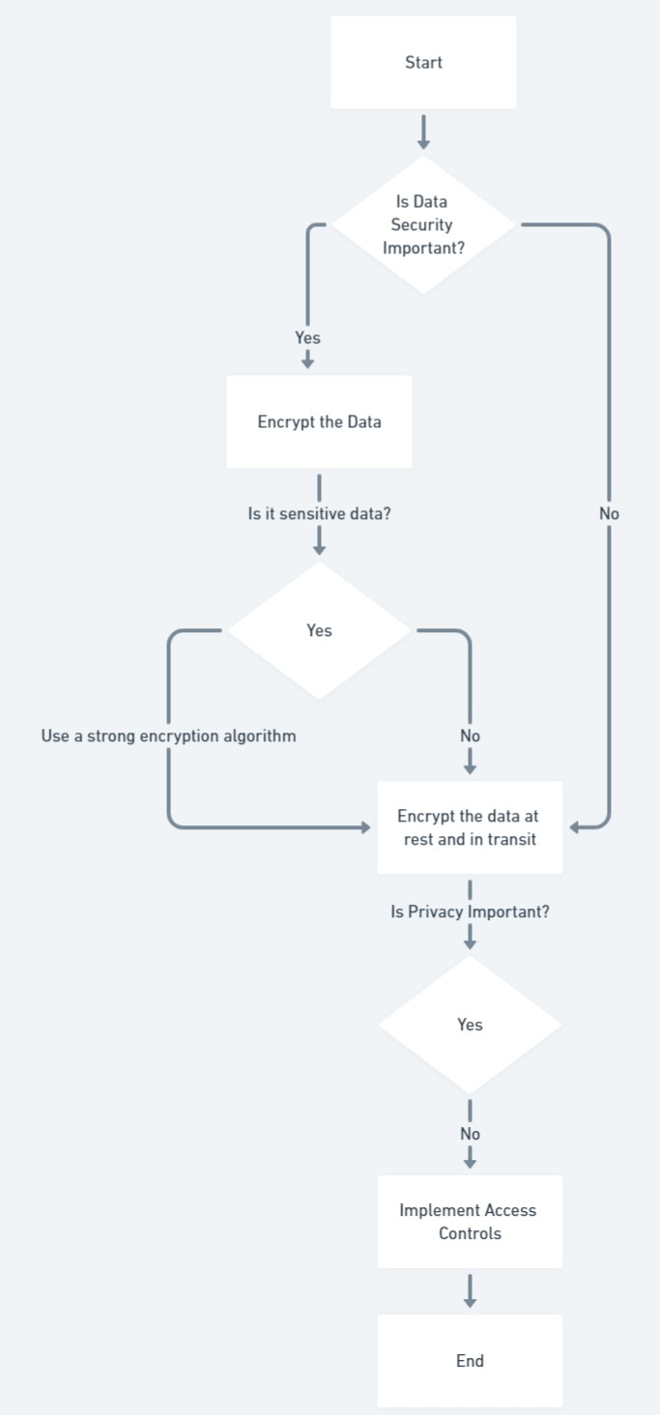

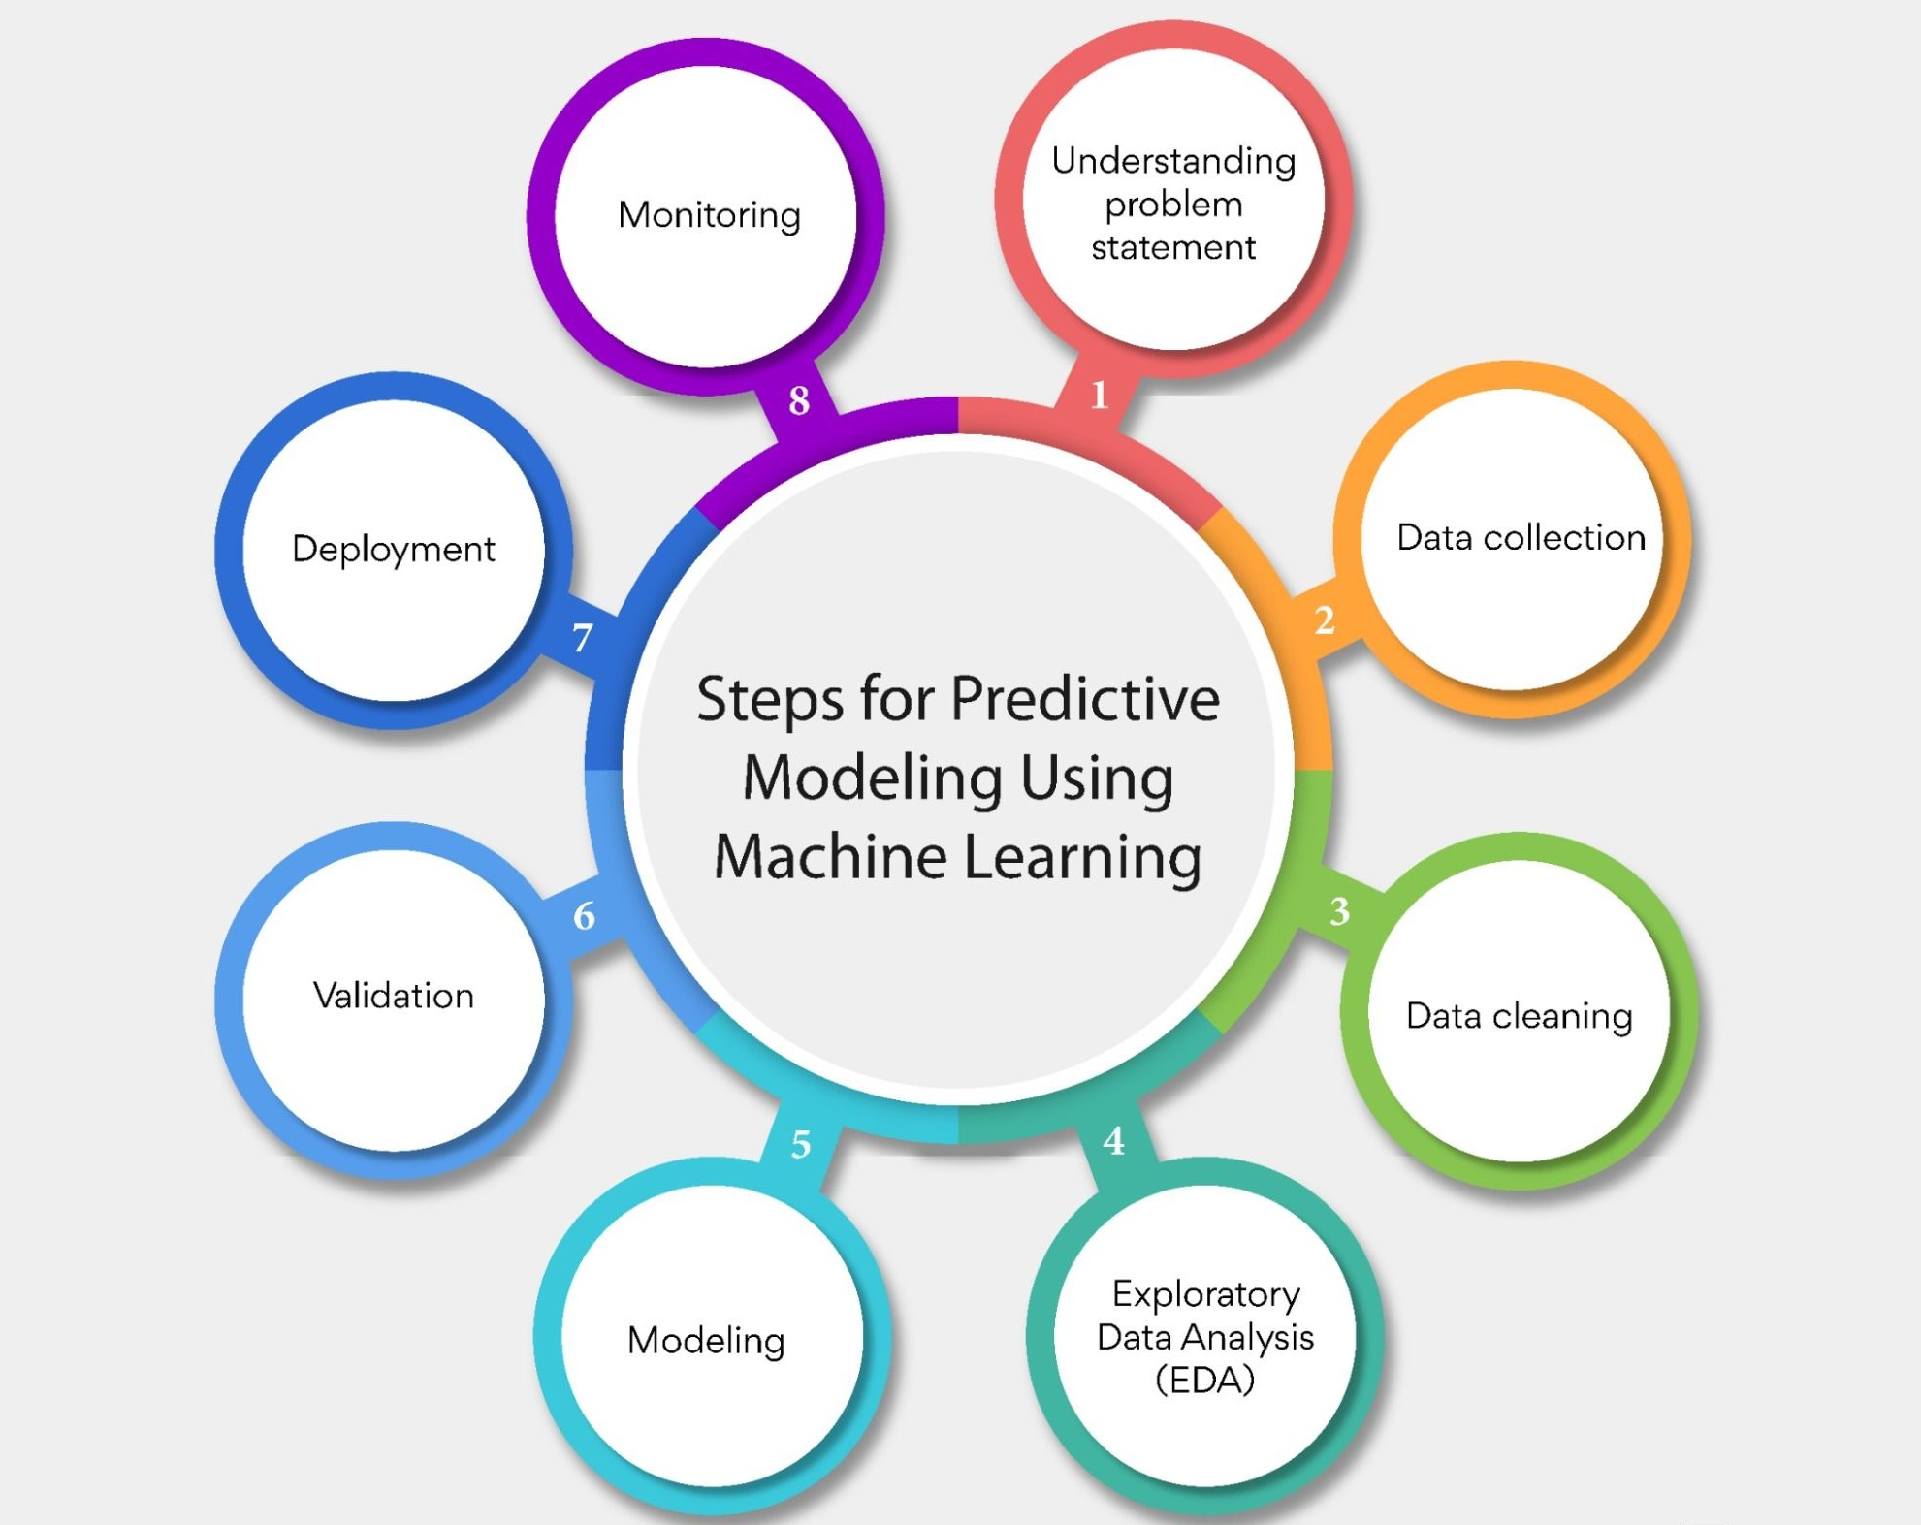

**5.Conclusion:**

In conclusion, employing advanced machine learning algorithms for predictive analysis in data security and privacy within the context of big data analysis using IBM Cloud datasets is essential for establishing a robust and proactive defense against evolving threats. The integration of sophisticated algorithms not only enhances the accuracy of threat detection but also contributes to a more comprehensive and adaptive security posture.